PAYROLL INSTRUCTIONS

Before beginning payroll determine from the payroll schedule whom you are paying;

1. Basepay, this includes firefighters and hourly members
2. 1/26+OT, this firefighters and hourly members, however timecards for firefighters need to be collected from the operations chief
3. Stipend pay period (this will be combined with either option 1 or 2), includes reservist and board members. Operations chief will provide reservist stipend amounts
4. Now you are ready to begin.

1. Locate the Payroll Worksheet in the Shared file.

1. Go to Computer 🡪 Shared (S) folder 🡪 Accounting🡪 Payroll🡪Choose Basepay or OT payroll worksheet
2. Change the date to current pay period and save

2. If this is a Basepay period;

1. Collect timesheets for the hourly staff and transfer totals to the payroll worksheet into the Hourly tab
2. If this is also a stipend pay period; collect reservist sheet from operations chief and enter into the Reservist tab, list the board members on the hourly tab each is paid $100

3. If this is an 1/26 + OT period;

1. Collect timesheets from operations chief and enter data into the FF hourly tab

***Basic Info Payroll Spreadsheet***

* *Base pay amounts always stay the same* ***ER*** *= amount FRFR pays to FPPA*
* *Premium = +10 hours* ***EE*** *= amount the employee pays to FPPA*
* *Schedule A = 91 hours (Base)* ***HSA*** *= Health Saving Account, $128.84 taken*
* *Schedule B = 101 hours (Base + Premium) out every two weeks; goes into a bank acct*
* *Stipend and BoDs paid at the same time the employee provides*
* *Reserve payroll info comes from Covillo;* ***457*** *– amount stipulated by the employee*

*retrieve from DropBox*

* ***FPPA*** *(9%) only taken out of base pay (not OT)*

**Base Pay Payroll:**

1. Open the **FRFR Operations** account in Sage
2. Get timesheets from DropBox
3. In the **Shared Folders** > **Accounting**, open the file folder **Payroll** > **Year** > **Pay Period** > **Payroll Worksheet**, keep both Sage and this spreadsheet open
4. In Sage, look up the last direct deposit number by going to **Reports** > **Accounts Payable**

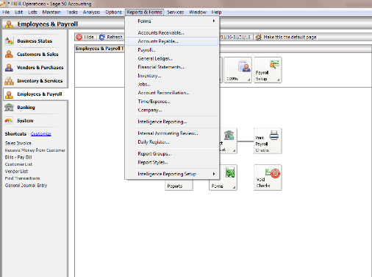

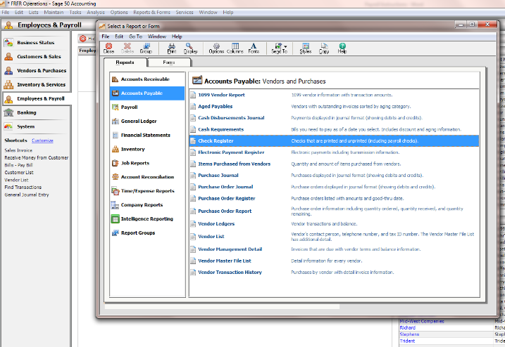**> Check Register:**

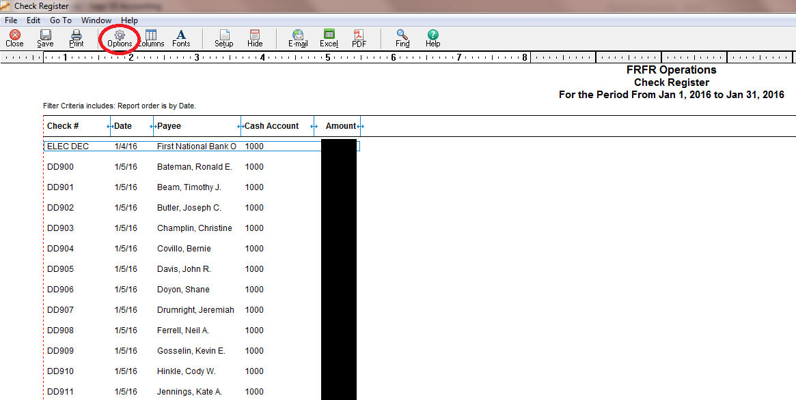> **Options:**

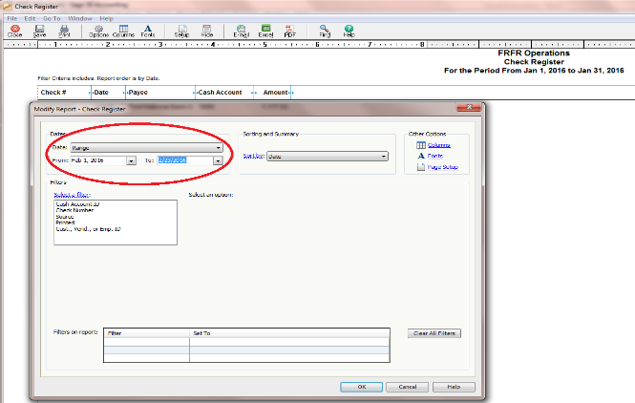> **Date Range** > **Ok**

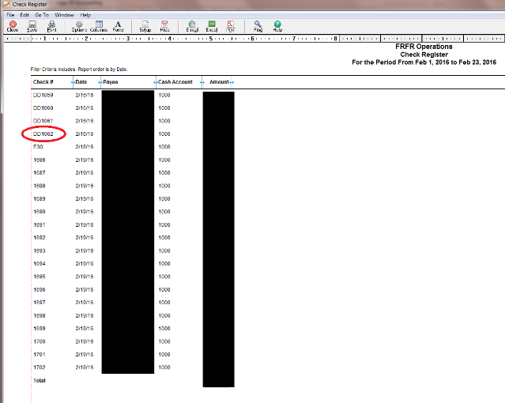**Note the last DD# This will be entered later in the process.**

1. 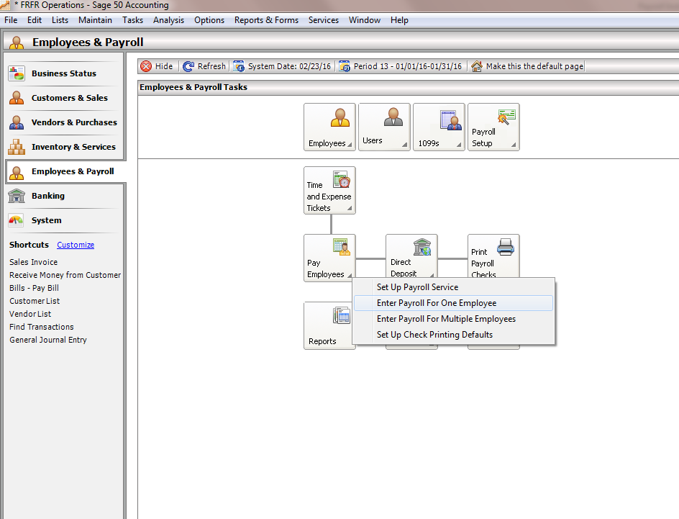Close and go to **Employees & Payroll** > **Pay Employees** > **Enter payroll for one employee:**
2. 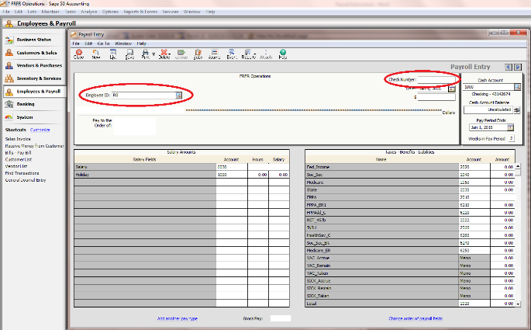Enter the employee’s initials into **Employee ID field** to pull up their info.
3. Enter dates. **Date of Check** is the day the check will be deposited (Tuesday), **Pay Period** is the last day of that pay period for line employees:
4. Enter Base our hours for each member. Then enter **deductions** from the spreadsheet on the right side of the column :

* *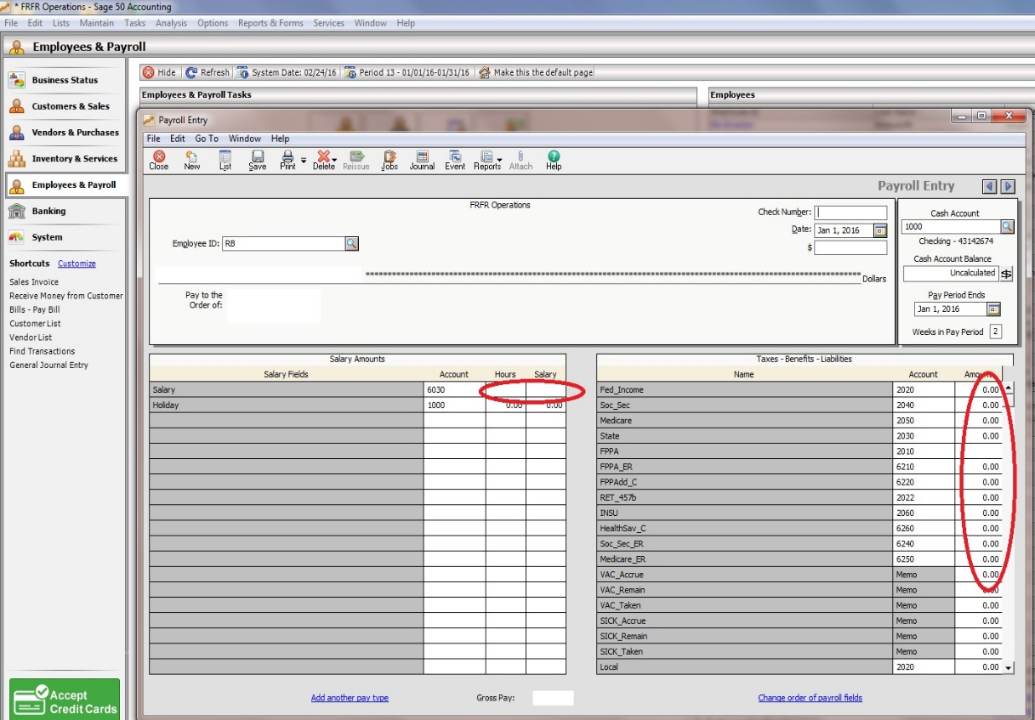For line personnel, amount stays the same as on spreadsheet*
* *For admin and hourly employees, enter hours from timesheets*

1. Write total **net pay** **in Payroll Worksheet** spreadsheet (at the end of each employee’s line.)
2. Click **Print** > **Print**, this prompts a document save box. Save this in **Payroll Retention**> **2016** > **New folder** with payday date. **This is when you will enter the check number.**
3. After all employees are entered into Sage, generate reports, go to **Reports** > **Payroll** > **Check Register** > **Export to Excel** spreadsheet. In Excel, remove all admin personnel and put in a separate column/row, total all amounts. **Save** spreadsheet to **Shared Folders** > **Accounting** > **Payroll** > **Year**
4. Also generate report **Payroll Bi-Monthly Register** in Sage (same as above). From this report, fill in the tax deductions into the **Payroll Worksheet** > **Check Register** tab/page

* *For SS and Medicare, you will need to double these amounts ($300 = $600)*
* *Check that the totals on each of the above reports match up (OK to be off by a few cents)*

1. Open the **First National bank account** online, go to **Transactions** > **Banking Accounts** > **ACH**
2. Click **Fed, SS, Med** > **Click again** > Check the **Tax Period** > **Add** Fed, SS, Med, etc
3. From the **ACH Database** list > **Flex Savings** > **All** > Check **Health Savings**, **State**, **ER** and **EE** > Enter amounts from spreadsheet
4. **ACH Database** > **Payroll** > **All** > Enter amounts from spreadsheet

* *For Nat Kronholm, take $250 of his pay and put it in his savings account. You’ll see this account right below the checking account line.*

1. Compare totals in bank list against your reports > **Save**
2. **ACH Database** list > Click **Payroll**, Fed/Med/SS, etc > **Create Batch**

* Either Chief can release the payments